Warm Up – Plyos – Accel - Max V Cues Guide/Cues

Dynamic Warm-Up (All Sessions)
Goal: Raise core temperature, prime elastic tissues, and rehearse mechanics.

Phase A – March/Drill Prep (perform each for 2 x 20-30m)
- A-march
  - Lift thigh to hip height, dorsiflex the foot (toes up) – heel to glute - step over and down opposite knee
- B-march
  - Knee up – toe up – thigh at maximum - extend the leg forward - pull foot back (“paw-back”) beneath hips – stay tall
- A-skips
  - A March Mechanics - Add a small hop off the support leg - Drive the knee up, hop once, then hop again as recovery foot lands. Keep toes up – Chest Tall
- B-skips
  - B March Mechanics - Add a hopping motion: knee high, leg straightens, then paw-back - Focus on hamstring engagement and pulling foot beneath hips.
- High Knees
  - Dorsiflexion in ankle – heel up to glute – thigh high – step over opposite knee and back down
- Straight-leg bounds
  - Bound forward with minimal knee bend - legs remain nearly straight – Dorsiflexion - strike ground under hips - Emphasize quick, springy contacts and maintain rhythm.
- 2 x 60m strides @ 70-80%

Phase B – Mobility & Activation (perform each for 10-20m)
- Toe Grabs
  - Foot in front – heel on ground – toe up – reach and scoop at it
- Forward Walking Lunge
- Backward Walking Lunge
- Alternating Side Lunge
- Leg Swings x 10 each leg
  - Forward/Backward & Side to Side

Phase C – Acceleration Prep
- Wall Walks: 3 x 6 each leg
  - body from head, spine, toe at 45 degrees … walk up the wall … each step get a little taller … just like you are accelerating – start like you would pushing a car – each step rise until foot contact under center of mass
- Wall Punches: 3x5 each Leg
  - Body from head, spine, toe at 45 degrees … forcefully drive knees into direction of wall keeping good 45 degree posture … contacts landing behind center of mass (land where foot left off)
- 2 x 60m strides @ 80-90%

Plyometric Progressions & Diagrams
- Pogos – think pogo stick without the pogo stick
  - Feet together - quick ground contact – explode off ground
  - Ankles rigid - Knees soft (minimal bend)
  - Arms at sides - Bounce vertically (no forward drift)
- Squat Jumps
- Start: quarter squat → explode up → land softly → reset
Cues: tall chest, knees track toes, full hip extension
- Tuck Jumps
  - Explode up → tuck knees to chest → quick land → minimal ground time
Cues: punch the ground - absorb softly - maintain posture

Plyometric Guidelines
- Ground contact: fast and stiff (except squat jumps)
- Be explosive – spend as little time on ground as possible

Proper Acceleration Mechanics
- Posture: forward-lean “straight line” from ankle to head (no hinge at hips).
- Projection: drive out at 45° in first steps; gradually rise each step … like a plane taking off
- Step model: increasing step length, quick ground contacts; foot strikes behind/beside COM.
- Arm action: aggressive; hands from cheek to pocket, elbows ~90°.

Pictures of proper acceleration mechanics and gradual rise of body position

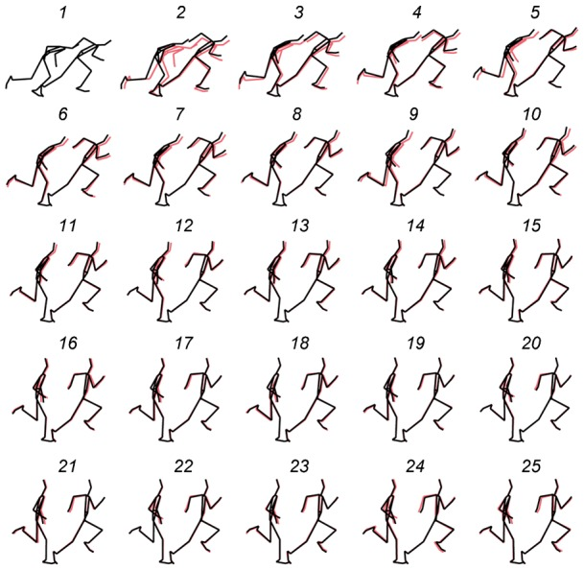

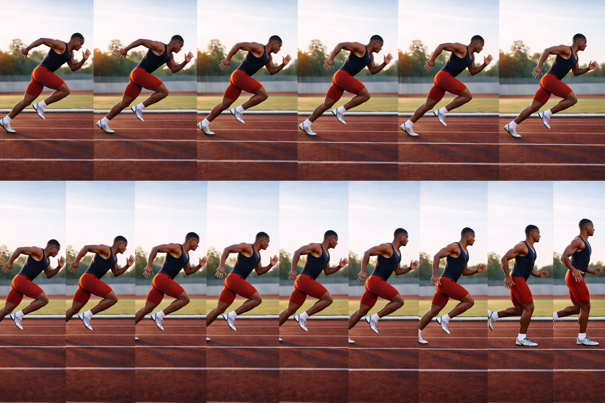

Max Velocity Mechanics (Flys)
- Posture: upright – tall – knee up – toe up – chest up
- attack over opposite knee and step down – under hip with dorsiflexed foot
- Front-side mechanics: knee up → heel under hamstring → down with vertical force.
- Arm action: cheek to cheek – straight down the track – don’t cross midline – move fast
- Fast AND Relaxed

Standing Start – Acceleration and Max Velocity Runs
- Feet
  - Front foot on or just behind the line
  - Back foot 6–12 inches behind (toe up or heel slightly raised)
  - Split Stance – like a wide receiver
- Hips & Torso
  - Hips slightly higher than shoulders
  - Torso angled forward (~45°)
  - Straight line from head → spine → back leg
- Arms
  - Opposite arm forward
  - Elbows ~90°
  - Hands relaxed
- Head & Eyes
  - Head neutral
  - Eyes down 1–2 meters ahead
- Cues
  - Drive out and up – big arm split – accelerate to top speed – like a plane taking off the runway

